Ms. Kara Hurst, VP, Head of Worldwide Sustainability
Amazon
410 Terry Ave. N
Seattle, WA 98109

Dear Ms. Hurst,

I am very concerned about the effects of non-sustainable palm oil production on rainforests in Indonesia and Malaysia. At the current rate of deforestation, orangutans and other wildlife will be extinct in just a few years.

As a consumer of your products, I’m urging you to please begin your journey toward sustainable palm oil by taking the following actions:

- Join the Roundtable on Sustainable Palm Oil (RSPO). www.rspo.org.
- Use only 100% physical certified sustainable palm oil (CSPO).
- When you begin using 100% CSPO, label your products with the RSPO trademark.
You will be advertising how environmentally conscientious you are!
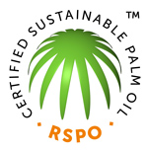

I would like to remain one of your loyal customers; however I am committed to supporting only those companies that are members of the RSPO and using 100% physical CSPO.

Amazon Brands:

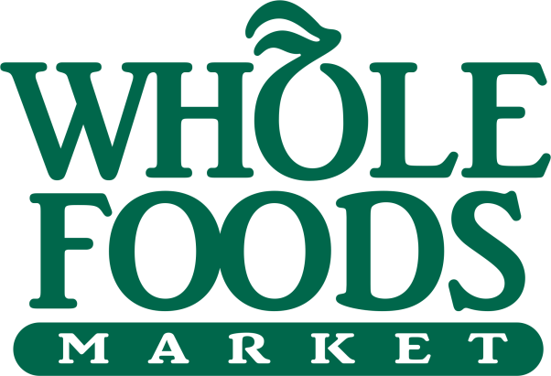



Thank you for your consideration.

